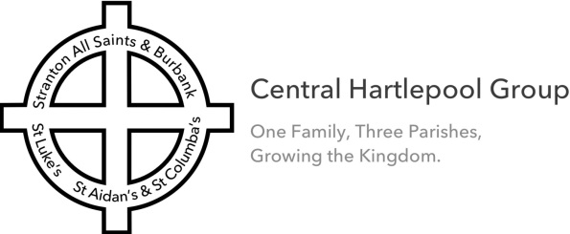
Notices and Readings 11 September 2022
St Luke’s and Stranton Churches
God’s Blessing as we gather together.

Today, upon her death, we pray for Her Majesty Queen Elizabeth II, her family, her church and the nation as we enter a 10 day period of mourning. 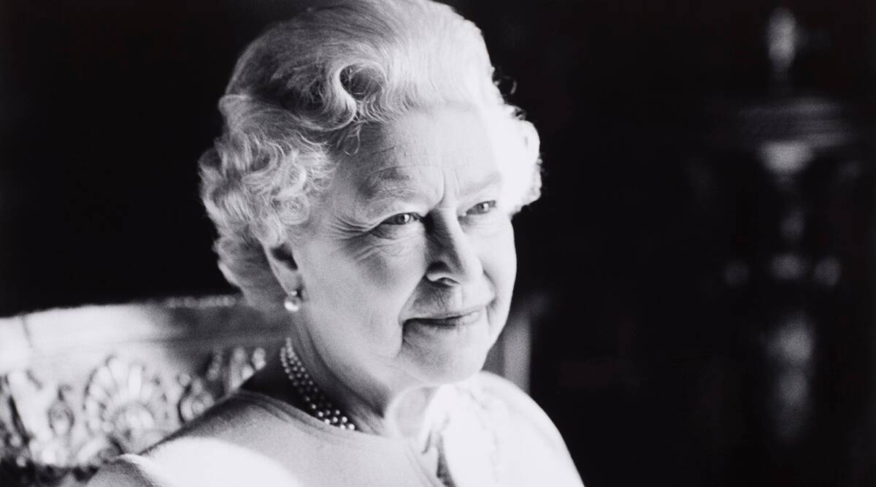
Some services will continue to be streamed LIVE on St Luke’s, St Aidan’s or Stranton Facebook, or Stranton web pages at the times shown below, and afterwards as online web page videos.

THIRTEENTH SUNDAY AFTER TRINITY Purple Streamed to Facebook…
9.00am Holy Communion, Stranton Revd Clive Stranton
9.15am Parish Eucharist, St Luke’s Archdeacon Rick Simpson
Reader Nathaniel Jackson
Intercessions Julia Taylor
Screens Jordan English
10.45am NO Mass, St Aidan’s at Stranton
11.00am Family Communion, Stranton Archdeacon Rick Simpson Stranton
12.30pm Baptisms, St Aidan’s Revd Michelle

Hymns: Intro SoF902 Lord of all hopefulness; Gradual SoF2 Abide with me; Offertory SoF200 I am the bread of life; Comm SoF1065 Thy hand O god has guided, Comm SoF470 Praise to the Lord, the almighty; Final SoF551 Thine be the glory.
Wednesday 14 Sept St Luke’s:
9.30am Holy Communion BCP Revd Michelle St Luke’s
Wednesday 14 Sept St Matthew’s:
10.00am Holy Communion Revd Clive Stranton
Thursday 15 Sept St Columba’s:
9.15am Mass Revd Michelle St Aidan’s

Collect:
Post Communion:
God our creator,
you feed your children with the true manna,
the living bread from heaven:
let this holy food sustain us through our earthly pilgrimage
until we come to that place where hunger and thirst are no more;
through Jesus Christ our Lord.
Amen
Almighty God,
the fountain of all goodness,
bless our Sovereign Lord, King Charles,
and all who are in authority under him,
that they may order all things in wisdom and equity, righteousness and peace,
to the honour and glory of your name and the good of your Church and people;
through Jesus Christ your Son our Lord,
who is alive and reigns with you,
in the unity of the Holy Spirit,
one God, now and for ever. Amen.

Readings:
1 Timothy 2: 1-6 NRSVA

Instructions concerning Prayer
2 First of all, then, I urge that supplications, prayers, intercessions, and thanksgivings should be made for everyone, ² for kings and all who are in high positions, so that we may lead a quiet and peaceable life in all godliness and dignity. ³ This is right and is acceptable in the sight of God our Saviour, ⁴ who desires everyone to be saved and to come to the knowledge of the truth. ⁵ For
there is one God;
there is also one mediator between God and humankind,
Christ Jesus, himself human,
⁶ who gave himself a ransom for all
—this was attested at the right time.
This is the Word of the Lord Thanks be to God

Gospel reading
Luke 22: 24-30 NRSVA

The Dispute about Greatness
²⁴ A dispute also arose among them as to which one of them was to be regarded as the greatest. ²⁵ But he said to them, ‘The kings of the Gentiles lord it over them; and those in authority over them are called benefactors. ²⁶ But not so with you; rather the greatest among you must become like the youngest, and the leader like one who serves. ²⁷ For who is greater, the one who is at the table or the one who serves? Is it not the one at the table? But I am among you as one who serves.
²⁸ ‘You are those who have stood by me in my trials; ²⁹ and I confer on you, just as my Father has conferred on me, a kingdom, ³⁰ so that you may eat and drink at my table in my kingdom, and you will sit on thrones judging the twelve tribes of Israel.

This is the Gospel of the Lord Praise to you, O Christ
Intercessions
- We pray: Eternal God, our heavenly Father, we bless your holy name for all that you have given us in and through the life of your servant Queen Elizabeth.
- We pray for peace where there is conflict, relief for refugees and the dispossessed, freedom for the oppressed: We pray for relief for the people of Ukraine, and all in conflict zones
- We pray for unity between Christians. We pray for all Churches in Hartlepool and for Churches Together Hartlepool. We pray for our joint outreach including the Foodbank.
- We pray that a new Group incumbent has been appointed to be inspired, led and guided by the Holy Spirit
- We pray that we may be a Community of Hope that we may reach out with love and hope to the vulnerable and marginalised. Pray for Aneta, Hayley, Viv and Emma, our Communities of Hope team as their work continues amongst the needy in our community.
- We pray for all those affected by the cost of living crisis, particularly remembering those in our town who have very little.
- We pray for peace and healing for all who are unwell in body, mind or spirit, especially for those awaiting medical treatment, or are in hospital or recovering at home, and for the doctors and nurses caring for them. We pray for those in isolation. We pray for those in care homes.
- We pray for all those who mourn; and we remember the family and friends of David Inman on the fifth anniversary of his death all those others we know who are grieving at this time.

NOTICES
ARRANGEMENTS FOR SERVICES on 11 and 18 September:
On the 11th instead of the Family Service we shall have the normal Eucharist Service with prayers for our dearly departed Queen and the new King. Church will be open from 8.00am.
On the 18th we shall have a special Holy Communion Service; both services to be held at the usual time of 9.15am.
Arrangements to open the church at other times will be discussed at PCC on Monday.
TEARFUND APPEAL: on behalf of the DEC (Disasters Emergency Committee) an appeal is made for funds to support the people affected by the massive floods in Pakistan. A plate is available at the back of church.
Next Messy Church: this afternoon at St Matthew’s Community Centre 4 pm
MACMILLAN COFFEE MORNING: on Saturday 17th September 11.00-12.00. Please bring your cakes to sell and your friends to buy!
COFFEE MORNINGS: a plea! We are desperate! for tombola and raffle prizes. The next coffee morning takes place on 22 October but we would be very happy to receive your contributions as soon as possible please. A box is at the back of church. We are doing a bottle tombola – any type of bottled produce will be most welcome! Thank you.
LEARNING COURSE: No Bible Study meetings this term, instead Revd Andrew and Revd Michelle will lead us at 7.15pm in the Parish Centre on Thursdays as follows: 22 September, 13 October, 10 & 24 November. This follows on from the very successful Racial Justice and Healing courses held earlier this year. All welcome.
HARVEST: will be on Sunday 2nd October. Donated store cupboard items will be split between Foodbank and Women’s Refuge.
Hartlepool Foodbank - Please support via COLLECTION POINT AT THE BACK OF CHURCH. The Foodbank currently needs - Tinned foods (Rice pudding, custard, tomatoes, soup, meat) Snacks (sweet & savoury).
OFFICE TIMES & HOLIDAYS: since we are looking to reduce heating bills and groups already meet on Tuesdays, Julia will change her working hours from a Monday to a Tuesday – as detailed below. Julia will be away from the office from Wednesday 21st September to Monday 26th September inclusive.

CHURCH IS OPEN FOR WORSHIP
Please use hand sanitiser before and after taking Communion.
Holy Communion is to be offered in three ways. Communicants will be directed to stand at the altar rail and with your hands held before you do one of the following:
  - to receive the bread, stand with your palms open
  - to receive bread intincted (dipped in wine) stand with your palms together, then open to receive
  - to receive the elements separately in the Fellowship of Christ; collect the bread at the altar, as above, then move across to receive the wine.
- If not taking Communion, please hold your hands down and you will receive a blessing
- Face coverings are no longer mandatory in any setting. Face coverings are encouraged mainly to protect others, not the wearer, from coronavirus; they are not a replacement for social distancing and regular hand washing.
- There will be no collection taken during the service but you may leave an offertory as you come in.
- Refreshments after the service are being served in the Parish Hall. Please maintain social distancing.
If you become unwell with COVID like symptoms within the week after attending a church service please advise a member of the clergy or a churchwarden.
DONATIONS: The plate is available to receive your donations and the contact-less pay station. We prefer if you’re making a regular donation to use on-line banking, our account details are: St Luke’s PCC, NatWest Bank Sort Code 55 81 04, Account Number 05609518. And please indicate if we can claim Gift Aid on your donation. There is a scheme, Parish Giving, that makes things simpler – please speak to our Treasurer, Stephen, about this. Thank you.
FIRE DOORS: Please ensure that all the doors in the Parish Centre are left closed.
HOME COMMUNIONS: Request cards are placed at the back of church to be completed for either Home Communion or other visits, or call the office.

Contacts: Church offices, please telephone or email.
For St Luke’s Tel 01429 281122 (Julia) Email: enquiries@stlukeschurch.plus.com
working hours are Tuesdays 10.00-1.30 and Wednesdays 10.00-4.00.
For Stranton Church Tel 07305 550009 (Trish) Email: admin@stranton-church-org.uk
For St Aidan’s Tel 01429 871814 (Kathrine) Email: staidans.hartlepool@btconnect.com
Confidential enquiries or requests can be made to Revd Michelle 07564 029010 or to Revd Clive 01429 278504.
Please note clergy usual “Days off” are: Fridays (Revd Michelle) and Thursdays (Revd Clive): if you have difficulty reaching them (for example during holiday periods) please ask the Church office to contact one of the Clergy to call you back.

St Luke’s Parish Safeguarding Officer
Maggie Hammond Tel 01429 872066 Email: confusedmag@hotmail.com
Facebook, Website & YouTube Addresses:
The 11:00am service at Stranton is now being streamed to: https://www.youtube.com/channel/UCMNoiSa2KGgGWkzIi62VFcA.
Other streamed services for Stranton Church are on Facebook Page. https://www.facebook.com/allsaintsstranton/ (which is also linked from http://stranton-church.org.uk"

https://www.facebook.com/stlukeshartlepool
https://www.facebook.com/aidancolumba/
https://www.facebook.com/hartlepoolcoh

NEXT SUNDAY 18 September The Fourteenth Sunday after Trinity (purple)

9.00am Holy Communion, Stranton Revd Michelle
9.15am Parish Eucharist, St Luke’s Revd Clive
Reader Alan Brown
Hymn chooser Julia Taylor
Intercessions Christine Amjad-Ali
Screens Jordan English
Sacristan Sheila Anderson
Greeter/Sidesperson Evelyn McAllister
Coffee Anne & Janine
Counting Evelyn & Maggie
Flowers Joanne Wheatley
Linen Maggie
10.45am Mass, St Aidan’s Revd Michelle
11.00am Holy Communion, Stranton Revd Clive
1.00pm Baptisms, Stranton Revd Clive

